cat -n filename
going to diplay the conect of file along with the line number

Du -ah is used to display size of every file and directory recursively in current path.
-a = include all files and directories

To display the top 10 largest files or directories in a server: du -ah | sort -rh | head -10

To delete empty lines in a file: sed -i '/^$/d' filename

To find empty line in a file and count them: grep -c '^$' filename
To find all the files owned by a specific user: find / -user username
find /data -user devops -type f -print0 | tar -czvf devops_files.tar.gz --null -T –
TOP vs HTOP
TOP focuses on the processes that consume the most system resources,
HTOP shows all running processes. htop also provides a rich-colored display and visual information about processor, swap, and memory status.

xargs passes the output of one command as input to another command, one value at a time in sequence.
example:
log1.txt (10 days old)
log2.txt (45 days old)
log3.txt (60 days old)
find . -type f -mtime +30 | xargs rm
It will delete only log2.txt and log3.txt (because they are older than 30 days).
If your manager wants you to find and delete all files that end with .log (like error.log, txt.log, etc.), you can use the find command with a pattern match and -exec to remove them
find /path/to/search -type f -name '*.log' -exec rm -rf {}

Note: The asterisk * is a wildcard that matches any number of characters

Q: I am not owner but I have all the permissions rwx
What and all operations I can perform
I can perform all the operations. Except-
I cannot change ownership (needs root privilege).
-You cannot change permissions unless you are owner or root.
write a script to check whether the given number is odd or even
#!/bin/bash
echo "Enter the number"
read n
if [ $(( n % 2 )) -eq 0 ]
then
echo "$n is even"
else
echo "$n is odd"
fi
#Prog to check even or not, if odd number should be divisible by 3

#! /bin/bash

echo "Enter the number $num"
read num
if [ $(($num % 2)) -eq 0 ]
then
echo "$num is a even number"
else
echo "$num is odd"
if [ $(($num / 3)) -eq 0 ]
then
echo "$num is odd number"
else
echo "$num is divisible by 3"
fi
fi
write a script to get the table of 10
#!/bin/bash

echo "Enter the number "
read table
i=1
while [ $i -le 10 ]
do
result=expr $table \* $i
i=expr $i + 1
echo "the result is \n $result"
done
Fibonacci Series

#!/bin/bash

echo "Enter the number:"
read n

a=0
b=1

count=0
while [ $count -lt $n ]
do
echo "$a"
next=$((a + b))
a=$b
b=$next
count=$((count + 1))
done
Write a shell script to find the sum of n number and each time it has to ask enter number 1, enter number 2 and so on

#!/bin/bash
echo "enter the number you want to add"
read n
i=1
while [ $i -le $n ]
do
echo "enter number $i"
read num
sum=expr $sum + $num
i=expr $i + 1
done
echo "sum of $n numbers is $sum"
Write a program to check whether a specific file exists inside the directory

#!/bin/bash

echo "enter the path of directory"
read directory

echo "Enter the filename you want to search"
read file

if [ -f "$directory/$file" ]
then
echo "Files exist inside $path"
else
echo "No files found inside $path"
fi
WAP to revers the string and check the string is palindrome or not using while and with out using "rev" command
how to check cpu consuming more then 50%: top press o %CPU>50
For Loop: To fetch the elements of an array in a sequence.
ex: num="2 4 5"

Syntax:

for variable in $num
do
statements
done

__________________________________________________________________

Example: Write a program to find factorial for the set of values.

#!/bin/bash

num="2 4 5"

for n in $num
do
fact=1
temp=$n

while [ $n -gt 0 ]
do

fact=expr $n \* $fact
n=expr $n - 1
done

echo "The factorial of $temp is $fact"

done
___________________________________________________________________________

Example-2: Write a program to find sum of all the elements in an array.

#!/bin/bash

num="2 8 9 6 5"

sum=0

for i in $num
do
sum=expr $sum + $i
done

echo "The sum of all the elements in array is $sum"
_____________________________________________________________________________

Example-3: Write a program to rename all text\.sh file into html files

#!/bin/bash

ls *.txt > out

while read line
do

name=echo $line | awk -F "." '{print $1}'

mv $name.txt $name.html

done < out

ls *.html

1. How to check if a package is installed
dpkg -s <package_name>
OR
apt list <package_name> --installed

2. How to delete a user account
sudo userdel <username>

3. How to check the size of a directory under root
sudo du -sh /root/mydirectory

4.How to remove or uninstall a package from the server
sudo apt remove <packagename>

#!/bin/bash

THRESHOLD=80 # % CPU usage limit
EMAIL="you@example.com" # Email to notify

# Stress CPU for 1 minute
stress --cpu 4 --timeout 60s &

# Check CPU usage every 5 seconds
while true; do
CPU=$(mpstat 1 1 | awk '/Average/ && $12 ~ /[0-9.]+/ {print 100 - $12}')
CPU_INT=${CPU%.*}

echo "CPU Usage: $CPU%"

if [ "$CPU_INT" -gt "$THRESHOLD" ]; then
echo "High CPU usage: $CPU%" | mail -s "CPU Alert!" "$EMAIL"
echo "Email sent to $EMAIL"
break
fi

sleep 5
done
Write a script to delete/cleanup old files:
#!/bin/bash
ls -lrt | awk -F " " 'NR>1 {print $NF}' > output
total=cat output | wc -l
echo "enter the number of values to retain"
read count
value=expr $total - $count
head -$value output | xargs rm -rf

------------------------------------------------------
* * * * * /home/ubuntu/file1.sh
1* - represent the minutes(0-59)
ex: 05(5 mins)

*/10 : It will execute for every 10 mins

2* - represents hours (1-23)
3* - represents date (1-31)
4* - represents month (1-12)
5* - represents day(Sunday-00, Monday-01, tuesday-02....)

Ex: I need to schedule a script on 7th november at 10.25 PM
25 22 07 11 * /home/ubuntu/filename.sh

I need to run a script for every 20 mins on monday and thursday
*/20 * * * 01,04 /home/ubuntu/filename.sh

I need to run a script for every 20 mins on Monday to thursday
*/20 * * * 01-04 /home/ubuntu/filename.sh

crontab : It is a scheduler which is used to schedule a scripts in Linux.
crontab -e : It is used to schedule the scripts in cronjob file.
crontab -l : It is used to list the scheduled scripts in crontab.
#!/bin/bash

day=date "+%a"
case $day in
'Mon') mkdir -p /home/ubuntu/tmp
;;
'Tue') find /home/ubuntu -type f -mtime +30 > filelist
;;
'Wed') cat filelist
;;
'Thu') ls -ltr /home/ubuntu
;;
'Fri') sudo adduser manasa
;;
'Sat' | 'Sun') echo "It's holiday"
Esac
synt: case variable in
'val1') statement
;;
'val2') sataement2
;;
'val3') statement3
;;
*) statement
esac

If value is a integer

synt: case variable in
val1) statement
;;
val2) sataement2
;;
val3) statement3
;;
*) statement
Esac
Write script to find all the files in /tmp directory and have to delete it and before delete them it should
ask for confirmation.

#!/bin/bash
files=$(find /tmp -type f)
if [ -z "$files" ]
then
echo "No files found in /tmp."
exit 0
fi
echo "The following files will be deleted:"
echo "$files"

read -p "Please confirm to delete the files (Y/N): " confirmation
if [[ "$confirmation" =~ ^[Yy]$ ]]
then
echo "$files" | xargs -d '\n' rm -f
echo "Files are deleted."
else
echo "Files not deleted."
Fi
If you want to clear old logs that are older than three months, then check if the folder size is still greater than 100 GB. If it is, delete the logs that are older than two months, check the size again, and finally print a message saying 'Good to go now.
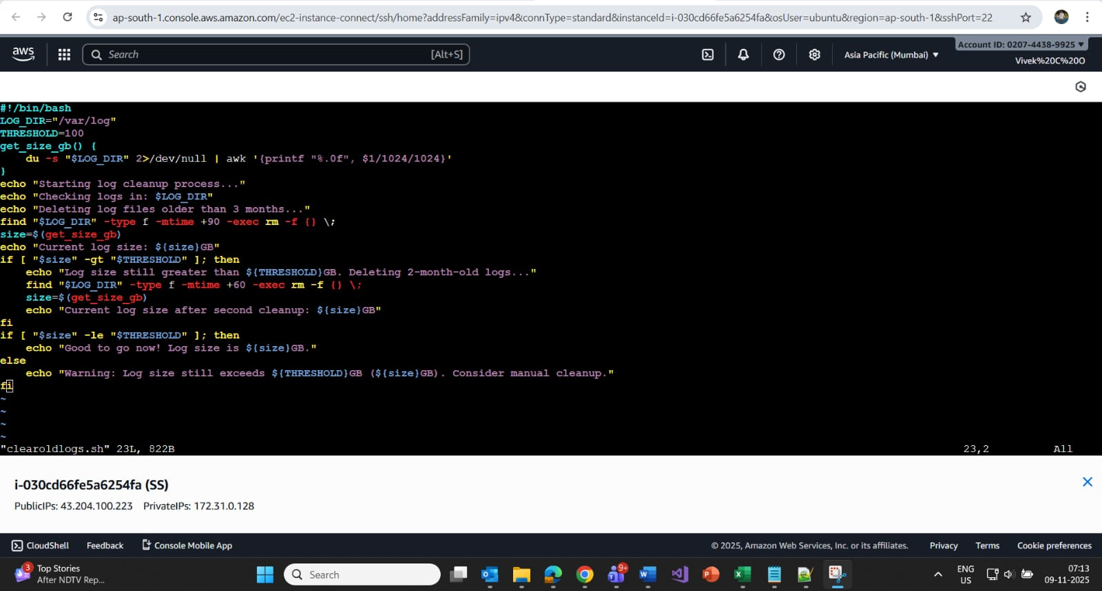

The folder to monitor is /etc/logs. Set the threshold to 95 GB. If the folder size reaches or exceeds 95 GB, send an email notification saying 'Memory is full, Please have a look
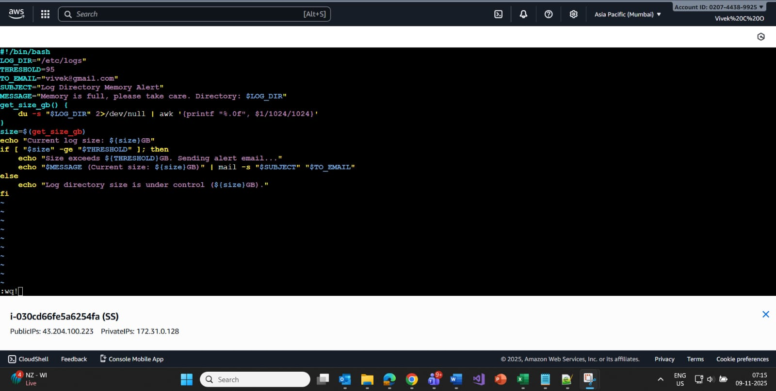

Write a script to check if servers are up and running. If a server is down, send an email to the concerned user.

!/bin/bash

echo "Enter the filename"
read serverls
if [ ! -f $serverls ]
then
echo "File not found"
exit1
fi
EMAIL=“yourmailid@gmail.com"
while read server
do
ping -c 1 $server
if [ $? -ne 0 ]
then
echo "$Server is down" | mail -s "$Server is down" $EMAIL
else
echo "$Server is up and running"
fi
done < $serverls
What command do we use to delete #commented lines in all the scripts at a time??
find . -type f -name ".sh" -exec sed -i '/^[[:space:]]#/d' {} +

How to give admin access to the user:
usermod -aG sudo username
username ALL=(ALL) NOPASSWD: ALL
Write a script to read count of numbers and find sum of all number
#!/bin/bash
echo "Enter the count of numbers:"
read n
sum=0
i=1
echo "Enter $n numbers:"
while [ $i -le $n ]
do
read num
sum=expr $sum + $num
i=expr $i +1
done
echo "The sum of $n numbers is: $sum"
Write a script to count the digits/tokens and print sum of the digits

#!/bin/bash
echo "Enter a number"
read num

current_num=$num
sum=0

echo "Numbers from $num"
while [ $current_num -ge 1 ]
do
echo "$current_num"
sum=$((sum + current_num))
current_num=$((current_num - 1))
done

echo "The sum of these numbers is $sum"
write a script to find sum of all elements in an array
#!/bin/bash
num="10 20 30 40"
for i in $num
do
sum=expr $sum + $i
done
echo "The sum of all elements in array is $sum"
enter a nubmer 'n' and print the numbers with interval of 1 second
#!/bin/bash
echo "Enter a number:"
read n
i=1
while [ $i -le $n ]
do
echo $i
sleep 1 # wait for 1 second
i=$((i + 1))
done
Q: enter a string. The program will calculate and display the total number of words it contains.

echo "enter a string\sentences"
read input
total=echo "$input" | wc -w
echo "The total number of words in a string is $total"
To copy files between servers without passwordless SSH (i.e., no password prompt), you can use a PEM (Privacy Enhanced Mail) key file for authentication. This is common when connecting to cloud servers like AWS EC2. Here's how to do it:
Step-by-Step: Copy Files Using a .pem File
1. Ensure the .pem file is available and has correct permissions
chmod 400 my-key.pem

This restricts access to the key file, which SSH requires for security.
2. Use scp with the -i option
scp -i my-key.pem /path/to/local/file username@remote-host:/path/to/remote/destination

Example:
scp -i my-key.pem index.html ec2-user@54.210.123.45:/var/www/html/
3. Reverse direction (remote to local)
scp -i my-key.pem username@remote-host:/path/to/remote/file /path/to/local/destination
Q: I need to replace all occurrences of the word 'error' with 'debug' across all files identified by the .logsh extension, not just a single file, wherever such files are found.
find . -type f -name "*.logsh" -exec sed -i 's/error/debug/gI' {} +
- find . -type f -name "*.logsh": searches for all .logsh files under the current directory.
- -exec sed -i 's/error/debug/gI' {} +:
- sed -i: edits files in place.
- s/error/debug/gI: substitutes all case-insensitive matches of error with debug.
check duplicate lines from file
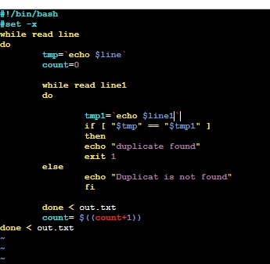

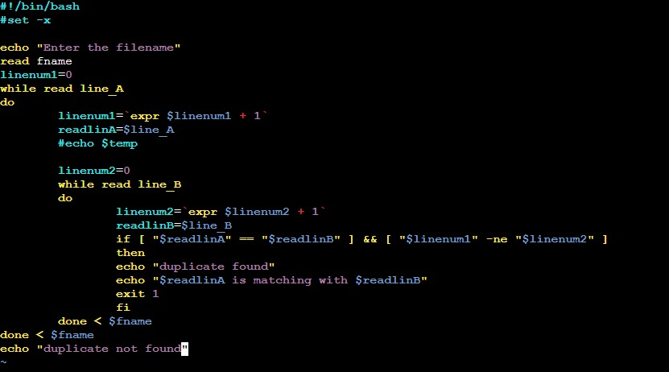

script to check top process is Jenkins and consuming cpu >75%
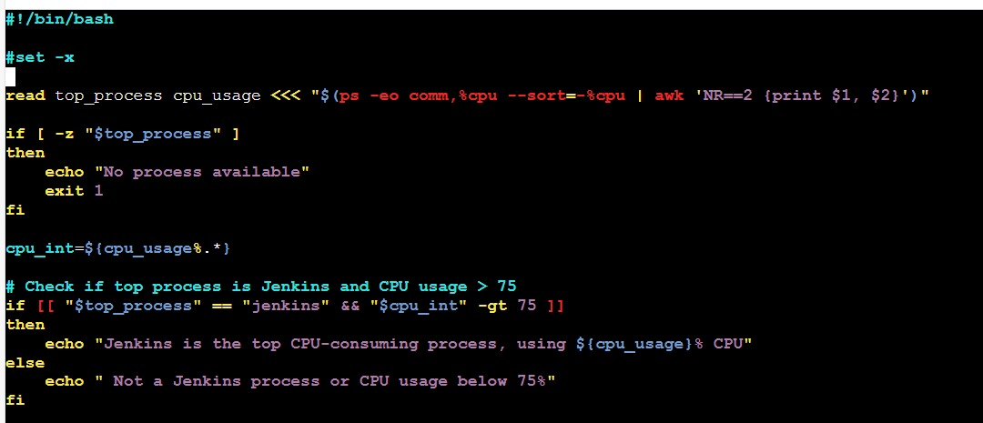
write a script to find the number is list of a array
#!/bin/bash

var=(10 20 30 40 50)

echo "Enter the number to search"
read num
i=0

for value in "${var[@]}"
do
if [ "$value" -eq "$num" ]
then
echo "given number is found in array"
i=1
exit 0
fi
done
if [ $i -eq 0 ]
then
echo "$num not found in array."

#else
#echo "$num found in array."
Fi
Linux command to be used to check the length of string
Syntax : ${#variable}
below is a sample program to check the length of string in shell script
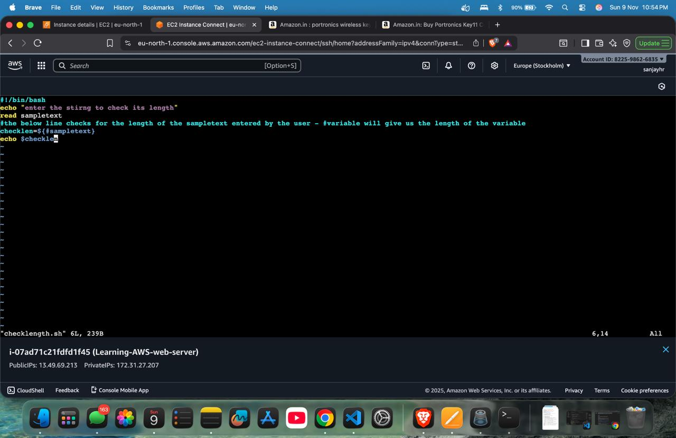
How to check if a variable is empty in Linux
*Syntax : -z $variable *
below is the sample shell script program to check if the variable is empty or not

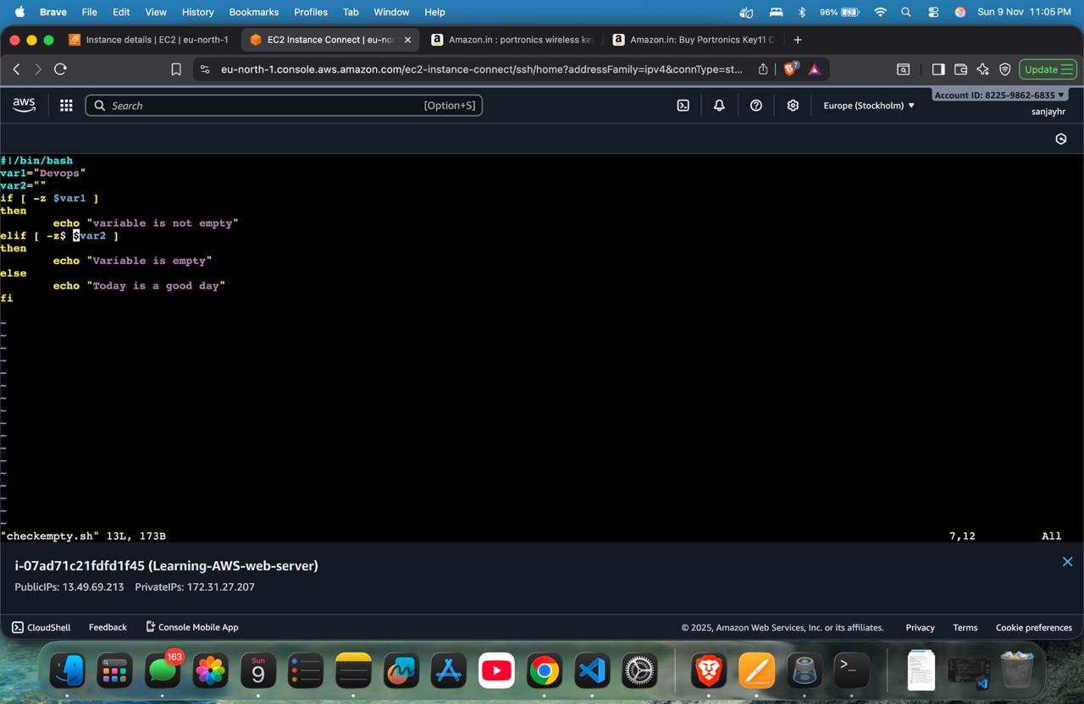

How to handle error in shell script
Syntax : set -e

Have u written any Automation Script?
Yes,
1. In a production environment, monitoring server health is critical. i built an automation shell script to continuously check system metrics and send alerts if resource usage reaches threshold value
2. To monitor the services, if any of the services stopped script will send mail notification to concerned person and it will restart the services.
3. also written cleanup script which will cleanup old builds and retain recent n builds.
Branching strategy:
Branches can be created for multiple reasons: here we create branches for releases, and we follow GitFlow as the branching strategy.

Our branching strategy has branches like feature branch, release branch, dev branch, master branch, hotfix branch.

Feature branch: Developers will create their own feature branch and merge into the dev branch.
Release branch: Release branch is used to maintain the releases
Hotfix branch: It is used to deliver the critical fix to the production environment.
Master branch: Master branch could be the replica of the production environment, it is always a clean branch.

Development will be going on the dev branch, once the code is ready for a first release on the dev branch, we create a separate branch for the first release.
And we make releases from the first release branch.
Whatever the issues related to the first release will be fixed on the first release branch.

Parallel development will be going on the dev branch for the second release.
Once the code is ready for second release on dev branch, before we create release2 branch, we merge the first release to the dev branch and then we create release2 branch for second release.
Whatever the issues we have seen in the first release will not be seen in the second release.
git remote -v -->It is used to check remote details of the repo URL.
git fetch --> It is used to bring the chnages from remote/Central repo to local repo and store the chnages in seperate branch in local repo.
We can review the changes and merger if it's required.
Synta: git fetch origin branch_name

git pull=git fetch + git merge

git amend-->It is used to add/modify the chnages to the previous commit
git commit --amend --> It will add the file to the previous commit by editing commit message
git commit --amend --no-edit --> It will add the chnages to the previous commit without editing commit message.

Q: Can we edit the commit message?
Ans: git commit --amend

Q: Types of Repo?
Ans: Bare Repo --> It acts as remote repo we can push and pull the code to this repo. We cannot run any git commands.
Syntax: git init --bare

Non bare repo--> It is a local repo where we edit the project related files. we can run any git commands
Syntax: git init

Q: How do I know how many files are modified under one commit?
Ans: git show commit_ID

Q: How do you check who modified each line of a code?
Ans: git blame filename

Merge conflicts--> It will occur when same line of code is modified on 2 different branches on same file, when we try to merge this chnages we get merge conflicts.

I don't no which chnages should I consider I'll check with Developers who modified the code on 2 different branchs, developers will discuss and come up with new chnage.
I'll put these chnages and continue with the merge

Q:How do yuo check who modified the files/code?
Ans: git log filename/git show commit_ID/git blame filename

Q: git bisect
validate - validate the project is correct and all necessary information is available
compile - compile the source code of the project
test - test the compiled source code using a suitable unit testing framework. These tests should not require the code be packaged or deployed
package - take the compiled code and package it in its distributable format, such as a JAR.
verify - run any checks on results of integration tests to ensure quality criteria are met
install - install the package into the local repository, for use as a dependency in other projects locally
deploy - done in the build environment, copies the final package to the remote repository for sharing with other developers and projects.
maven repo- while building the application ,maven search dependency first in local repo if it doesn't exist then it will search in central repo, if it doesn't exist in central repo then it will search in remote repo.

have you written pom.xml?
Usually pom.xml is given by dev team, we will edit pom.xml for path of local dependency.

settings.xml
settngs.xml will be on build server that is where compilation will be going on. We will update path for dependency JARs [Central Repo path or Credentials to upload or download the dependencies].
/ (Root)
Main folder which is root of everything(where every file and folder starts from here)
/bin
Contains basic commands (like ls, cp, mv, cat) which is used by all users.
/sbin
Commands needed by the system administrator (like shutdown, fdisk).
/etc
Contains all configuration files (settings).
/dev
Contains device files (hard disk, USB, keyboard).
/proc
Virtual files showing running processes & system info
/var
Contains Variable data: logs, cache, mail, spool.(changes frequently)
/tmp
Temporary files which will be automatically deleted sometimes.
/usr
It's a big directory Contains installed applications, libraries, documentation.
/home
Personal directories for each user. (eg: /home/username)
/boot
It contains files required to start the system (kernel, bootloader).
/lib
It contains System libraries needed for programs in /bin and /sbin.
/opt
it contains Optional or third-party software (e.g., Chrome, Tomcat).
/mnt
Temporary mount directory (used by admin).
/media
It automatically mounts removable devices: USB, External devices.
/srv
It contains Service-related data (like web server files, FTP files).
JAR File (Java ARchive)
A JAR file is used to package core Java applications, libraries, classes, and resources.
used in:
• Standalone Java apps
• Utility libraries
it contains:
• .class files
• META-INF/MANIFEST.MF
• Property files/resources

WAR File (Web Application ARchive)
A WAR file packages web applications that run on a Java web server (like Tomcat, JBoss, Jetty).
used in:
• Java web apps (Servlet/JSP)
• RESTful services deployed to Tomcat
it contains:
• HTML, CSS, JS
• JSP/Servlets
• WEB-INF/web.xml
• Libraries inside WEB-INF/lib
EAR File (Enterprise ARchive)
An EAR file packages enterprise-level applications consisting of multiple modules.
Runs on enterprise servers:
• WebLogic
• WebSphere
• JBoss EAP
it contains
• Multiple JAR modules
• Multiple WAR modules
Today Tasks:

Note: Make sure the port number should be changed to tomcat if it have default port number 8080. Because Jenkins will use the same port number.

Install the Jenkins

execute the commands

link for Jenkins Installation: https://www.jenkins.io/doc/book/installing/linux/

commands:

sudo apt update
sudo apt install fontconfig openjdk-21-jre
java -version

sudo wget -O /etc/apt/keyrings/jenkins-keyring.asc \
https://pkg.jenkins.io/debian-stable/jenkins.io-2023.key

echo "deb [signed-by=/etc/apt/keyrings/jenkins-keyring.asc]" \
https://pkg.jenkins.io/debian-stable binary/ | sudo tee \
/etc/apt/sources.list.d/jenkins.list > /dev/null

sudo apt update

sudo apt install Jenkins
Explain Branching strategy
explain about Gitlab runners
explain steps of gitlab pipeline
what kind of work you did in gitlab, enhancement work or scrach
explain how you create gitlab pipeline
How do you protect the release branch?
Have you worked on gitlab?
what is git stash?
difference git pull and fetch?
how hotfix branch works with example?
A developer does some wrong changes but he hasn't committed his changes, what are the steps he would perform to rectify it
How do you decide a branching strategy. What are the different branching strategies you are aware of
diff between git revert and git reset
Diff b/z git pull & clone
Explain the process of PR[pull request]
18. Write a script to read a statement and display the lengthiest word
#!/bin/bash

#set -x
echo "enter the statement"
read line
lengthy_word=""

for i in $line
do
if [ ${#i} -gt ${#lenthy_word} ]
then
lengthy_word=$i
fi
done
echo "the longest word in a statement is $lengthy_word"

=>ubuntu@ip-172-31-6-219:~$ ./test6.sh
enter the statement
I am all good morning
the longest word in a statement is morning
19. In git, there are thousands of files ready to commit but I want to skip 10 files and commit the remaining files. How?
=>. gitignore file is a special text file in a Git repository that tells Git: “Do NOT track these files.”
write a script to clean up the old files

#!/bin/bash
ls -lrt | awk -F " " 'NR>1 {print $NF}' > output
total=cat output | wc -l
echo "enter the number of builds to retain"
read count
value=expr $total - $count
head -$value output | xargs rm -rf
Script to generate Fibonacci Series

#!/bin/bash
a=0
b=1

for i in {1..10}
do
echo "$a "
temp=$((a + b))
a=$b
b=$temp
done
shell script to delete the log files if the files are lessthen 30 days and archive the files if the files are lessthen 10 days

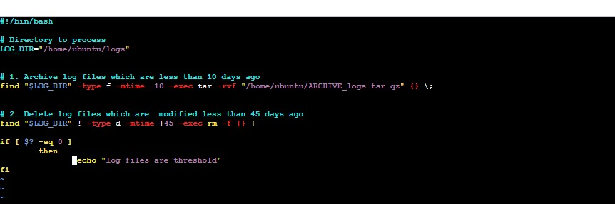

Scripts to count number of vowels in a word

#!/bin/bash
echo "Enter the word"
read word
len=${#word}
count=0
for (( i=0; i<$len; i++ ))
do
char=$(echo "$word" | cut -c $((i+1)))
if [[ $char == [aeiouAEIOU] ]]
then
count=expr $count + 1
fi
done
echo "Number of vowels is $count"
"Git disk" is not a specific, standardized term in Git or GitHub documentation; rather, it refers to the physical storage on a local computer or server that is used to house a Git repository.
send an alert message if CPU usage crosses 70% for all the drives

#!/bin/bash
usage=$(df -h | awk 'NR>1 {gsub("%","",$5); if ($5 > 70) print $1" "$5"% "$6}')

if [ -n "$usage" ]
then
echo "Memory usage reached threshold more than 70%" | mail -s “alert exceeds $usage” <mail I’d>
echo "$usage"
fi
#Write a shell script to enter the sentence and display the word with highest character.
#!/bin/bash

echo "enter a sentence:"
read string

longest=""
mxlength=0

for word in $string; do
length=${#word}
if [ $length -gt $mxlength ]; then
mxlength=$length
longest=$word
fi
done

echo "the word which highest number of characters is $longest"
echo "length: $mxlength"
How/where do you check logs in linux?
In Linux, logs are primarily stored and viewed -> /var/log/
Q: How Git tag is used in Git?
In Git, tags are used to mark specific points in a repository’s history as important—most commonly to label release versions (e.g., v1.0, v2.3.4). They act like immutable bookmarks pointing to a particular commit.

Types of Git Tags
1. Lightweight Tag
Just a pointer to a commit.
Think of it as a simple label.
syntax: git tag v1.0

2. Annotated Tag
Recommended for releases.
Stores metadata: tagger name/email, date, message.
Saved as a full Git object.
syntax:git tag -a v1.0 -m "Release version 1.0"
List all the open files which used by specific process
lsof -p PID

How to merge the changes from the 1st and 4th commits into a single commit
git cherry-pick -n <commitID-1> <commitID-4>
Q: How tags are used in Jenkins for versioning builds?
Jenkins can use Git tags to create versioned builds. This ensures every build corresponds to a specific, fixed version of your code.

Use Case 1: Trigger Jenkins Build on Tag Creation

In Jenkins → Git SCM configuration:
Set the branch specifier as:

refs/tags/*

This means Jenkins will build only when a new tag is pushed.

Use Case 2: Fetch a Build Using a Specific Git Tag

In Jenkins → Source Code Management → Branch Specifier:

refs/tags/v1.0

Jenkins will check out the exact code from tag v1.0 and build it.

Use Case 3: Automatically Version Build Artifacts Using Tag

In your Jenkins pipeline, you can read the Git tag:

Declarative Pipeline

pipeline {
stages {
stage('Build') {
steps {
script {
def TAG = sh(script: "git describe --tags", returnStdout: true).trim()
echo "Building version ${TAG}"
}
}
}
}
}

You can then name the artifact like:

myapp-${TAG}.zip

Use Case 4: Release Automation in Jenkins

Flow:

1. Developer creates a tag:
git tag -a v2.0 -m "Release 2.0"

2. Push tag to remote:
git push origin v2.0

3. Jenkins job detects tag → builds → produces

app-v2.0.jar

4. Artifacts are stored and documented with version v2.0
how do we see the history of only particular branch like dev?
git log dev

If you modified changes in master branch and you have to make those files to be present in dev branch and how will you merge those changes ?
Step 1: Commit your changes in master
git checkout master
git add .
git commit -m "Fix or new change"

Step 2: Move to dev branch
git checkout dev

Step 3: Merge master into dev
git merge master
This will bring the latest changes of master into dev.

If there are conflicts, resolve conflicts in the affected files and

git add .
git commit

✅ 14. Jenkins Server Not Running — How to Fix

Commands:

sudo systemctl status jenkins
sudo tail -f /var/log/jenkins/jenkins.log
sudo systemctl restart jenkins
sudo systemctl daemon-reload
df -h (check disk)
free -m (check memory)
ps -ef | grep Jenkins

*If the Jenkins master or slave is down, follow these quick steps:
*
If Jenkins Master is down:

Restart Jenkins service

Linux: sudo systemctl restart jenkins

Check resources (disk, RAM, CPU)

Check logs at /var/log/jenkins/jenkins.log

Ensure Java and port 8080 are correct

Reboot the server if needed

If Jenkins Slave/Agent is down:

Restart the agent service or reconnect SSH/JNLP

Verify network (agent must reach master)

Check disk space on the agent

Restart SSH (sudo systemctl restart sshd)

Reconfigure or recreate the agent if required

Q: Day-to-day Activities in Jenkins?

Monitoring Jenkins jobs and build pipelines

Troubleshooting failed builds and fixing pipeline issues

Managing Jenkins nodes/agents and checking their health

Creating, updating, and maintaining CI/CD pipelines (declarative scripts)

Installing, updating, and managing plugins

Managing credentials, environment variables, and secrets

Cleaning up workspace, logs, and old builds to save disk space

Integrating Jenkins with tools like Git, Maven, Docker, SonarQube, Nexus, etc.

Managing user permissions and security settings

Backing up Jenkins configurations, jobs, and plugins

Improving performance and ensuring high availability of Jenkins servers

Supporting development teams in CI/CD automation issues

Q. Where do you keep the secrets in Jenkins?

In Jenkins, secrets are stored in Jenkins Credentials Store, which is managed through:

Manage Jenkins → Credentials

Stored securely using Jenkins’ built-in credential provider

We store secrets like:

Passwords

API tokens

SSH keys

Secret text

Vault/token credentials

How to check git configuration values ?
git config –list

pipeline {
//agent { label 'Java'}
agent none
parameters {
string(name: 'cmd', defaultValue: 'default', description: 'A sample string parameter')
booleanParam(name: 'SAMPLE_BOOLEAN', defaultValue: true, description: 'A boolean parameter')
choice(name: 'cmd1', choices: ['install', 'compile'], description: 'Choose one option')
}
stages {
stage ('hello-world-war'){
parallel {
stage('Checkout') {
agent { label 'Java'}
steps {
withCredentials([usernamePassword(
credentialsId: '53798f27-0ed8-4bc5-84df-9e6c23bc5b73',
usernameVariable: 'Vivek_USER',
passwordVariable: 'Vivek_PASS'
/* withCredentials([sshUserPrivateKey(
credentialsId: '3f6a9c95-2ecd-4bbe-a817-1ab975fb98d3',
keyFileVariable: 'Vivek_SSH_KEY',
usernameVariable: 'Vivek_SSH_USER' */
)]) {
sh "rm -rf hello-world-war"
sh "git clone https://github.com/vivek-co/hello-world-war"
}
}
}

stage('Build') {
agent { label 'Java'}
steps {
sh "mvn clean package"
}
}

stage('Deploy') {
agent { label 'Java'}
steps {
// Example deployment command
echo "Deploying application"
sh "sudo cp /home/slave1/workspace/hello-world-war-pipeline/target/hello-world-war-1.0.0.war /opt/apache-tomcat-10.1.49/webapps"
}
}
}
}
}
}

⭐ Nightly Build (Definition + Examples)
Definition (Crisp):

A nightly build is an automated process that runs once every night to build, test, and validate the latest code without affecting daytime development.

⭐ Real-Time Examples (Crisp):

Run long integration/regression tests at midnight so developers aren't blocked during the day.

Execute heavy SonarQube + security scans overnight to ensure the main branch stays clean.

Generate a fresh build for QA every morning, such as a new JAR/WAR/Docker image automatically deployed to the QA environment.

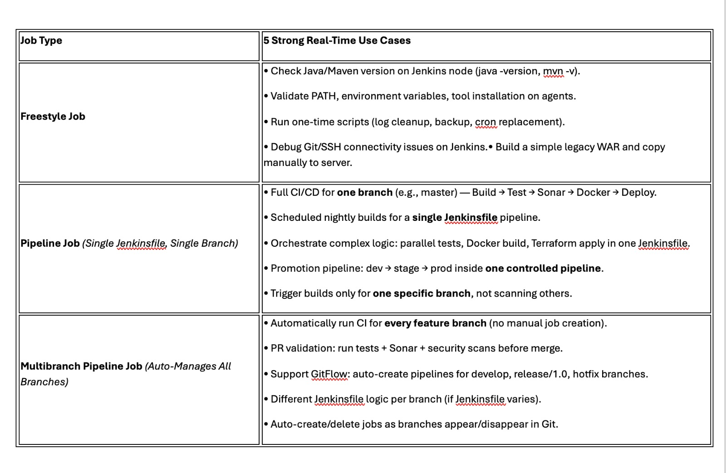
SonarQube Key Features:
Quality Gates:
Definition: A set of conditions that must be met before a project can be considered "clean" (e.g., no new issues, sufficient test coverage).
Purpose: Enforces coding standards and ensures code quality before deployment.
Example: Code must have at least 80% test coverage and no critical issues.

Quality Profiles:
Definition: A set of rules used to analyze code, which can be applied to different languages.
Purpose: Customizes analysis based on the project's requirements (e.g., Java, JavaScript, C++).
Example: A profile that checks for Java-specific rules like naming conventions and potential bugs.

Code Coverage:
Definition: Percentage of code tested by unit tests.
Importance: Measures test effectiveness and identifies untested code.
Tools: JaCoCo (for Java), LCOV (for C/C++).
Metrics: Line coverage, branch coverage.
Quality Gate: Can enforce coverage thresholds (e.g., 80%).

Code Duplication:
Definition: Identifies duplicate code blocks within a project.
Purpose: Helps reduce redundancy and improve maintainability.
Metrics: Percentage of duplicated lines.

Code Smells:
Definition: Detects maintainability issues in the code that may not be bugs but indicate potential problems.
Examples: Long methods, large classes, duplicate code.
Purpose: Helps improve code readability and maintainability.

Bugs:
Definition: Identifies potential coding mistakes that could lead to issues during runtime.
Examples: Null pointer exceptions, unhandled exceptions.
Severity: Categorized as Blocker, Critical, Major.

Vulnerabilities:
Definition: Finds security issues in the code.
Examples: SQL injection, XSS vulnerabilities.
Severity: Categorized as Critical, Major, Minor.

Issues:
Definition: General term for problems identified in the code (bugs, vulnerabilities, code smells).
Tracking: SonarQube provides a dashboard to track and resolve issues.
Severity Levels: Blocker, Critical, Major, Minor, Info.

Technical Debt:
Definition: A measure of how much rework is needed due to suboptimal code quality.
Purpose: Helps prioritize refactoring tasks.
Metric: Expressed as the time required to fix issues in the codebase.

Pull Request Analysis:
Definition: Analyzes pull requests to ensure new code meets the required quality standards before being merged.
Purpose: Prevents introducing new issues in the codebase.
SonarCloud Integration:

Cloud-based version of SonarQube.
Purpose: Automatically analyzes code in the cloud (no need for local installation).

Custom Rules:
Definition: Create and apply your own coding rules to fit your project needs.
Purpose: Enforces organization-specific coding standards.

SonarQube Workflow:
Configure Quality Gates and Profiles: Set rules and thresholds for code quality.
Analyze Code: Run SonarQube analysis as part of the build pipeline (via Maven, Gradle, or CI tools).
Track Issues: View issues like bugs, vulnerabilities, and code smells.
Enforce Coverage: Set coverage thresholds to ensure sufficient testing.
Resolve Issues: Fix identified issues and monitor improvements over time.

Which port SonarQube uses: 9000

Which plugin is used to get code-coverage in sonar
We use jococo as plugin to configure code coverage
I have scheduled a job by using crontab in that I have used a echo statement and that job was working 3 days back and now it is not working. How do I check

Step 1 : First in the echo statement we need to confirm where the output is going
Echo "hello" >> /tmp/test.log

Step 2: Check cron logs to confirm if the job ran
grep CRON /var/log/syslog

Step 3 : Check if cron service is running
sudo systemctl status cron

Q: Two parallel stages create logs; the final stage needs both. How will you share data?
“Since the parallel stages may run on different agents, I’d have each stage store its logs as artifacts in shared storage. The final stage would declare dependencies on those stages, download both artifacts, and then process or merge the logs. For example, in Jenkins I’d use stash/unstash, in GitLab/GitHub I’d use artifacts upload/download.”
parallel(
stageA: {
sh 'run-tests-a > stageA.log'
stash name: 'logsA', includes: 'stageA.log'
},
stageB: {
sh 'run-tests-b > stageB.log'
stash name: 'logsB', includes: 'stageB.log'
}
)

stage('Combine Logs') {
unstash 'logsA'
unstash 'logsB'
sh 'cat stageA.log stageB.log > combined.log'
}
Your deployment stage fails, but you want the pipeline to continue and end as SUCCESS.
How do you handle this with try–catch?

“I would wrap the deployment stage in a try–catch block. Inside try I run the deployment; in catch I log the error but do not rethrow it. That way the stage can fail internally, but the pipeline continues and still ends with a SUCCESS status. Optionally, I can set a custom variable or notify stakeholders.”

stage('Deploy') {
steps {
script {
try {
sh 'deploy.sh' // This may fail
} catch (err) {
echo "Deployment failed, but continuing pipeline..."
echo "Reason: ${err}"
currentBuild.result = 'SUCCESS' // Do NOT set FAILURE
// Optionally record that deployment failed
env.DEPLOY_FAILED = "true"
}
}
}
}
stage('Deploy') {
steps {
catchError(buildResult: 'SUCCESS', stageResult: 'FAILURE') {
sh 'deploy.sh'
}
}
}
We have a shell script file and want to have to check the list of versioned artifact and delete only the last 15 build artifact.--> pipeline should run once in every 7 days.

pipeline {
agent any
triggers {
cron('0 0 */7 * *')
}
stage('Checkout') {
steps {
rm -rf news-app
git clone URL
}
}
stage('Build') {
steps {
sh 'mvn clean package'
}
}
stage('Test') {
steps {
sh 'mvn test'
}
}
stage('Cleaning Artifacts') {
steps {
chmod +x cleanup.sh
sh './cleanup.sh 15'
}
}
}

2. In production deployement and perticular stage should only run after manual approval.

stage('Approval') {
steps {
input message: 'Deploy to Production?', ok: 'Deploy'
}
}

3. One Jenkins file should be used to deployed into multiple env.

pipeline {
agent any
parameters {
choice(name: 'DEPLOY_ENV', choices: ['dev', 'qa', 'staging', 'prod'], description: 'Select environment to deploy')
}
stages {
stage('Checkout') {
steps { checkout scm }
}
stage('Build') {
steps { sh 'mvn clean package' }
}
stage('Test') {
steps { sh 'mvn test' }
}

stage('Deploy to Dev') {
when { expression { params.DEPLOY_ENV == 'dev' } }
steps {
sh './deploy.sh dev'
}
}

stage('Deploy to QA') {
when { expression { params.DEPLOY_ENV == 'qa' } }
steps {
sh './deploy.sh qa'
}
}

stage('Deploy to Staging') {
when { expression { params.DEPLOY_ENV == 'staging' } }
steps {
sh './deploy.sh staging'
}
}

stage('Approval for Prod') {
when { expression { params.DEPLOY_ENV == 'prod' } }
steps {
input message: "Deploy to Production?"
}
}

stage('Deploy to Prod') {
when { expression { params.DEPLOY_ENV == 'prod' } }
steps {
sh './deploy.sh prod'
}
}
}
}
What is your role in the release?

“My role in the release process involves ensuring that the build, deployment, and delivery pipelines run smoothly, reliably, and efficiently. I participate in the entire release lifecycle—from preparing the environment to validating the final deployment.
Q: Connect to the Linux agent, install dependencies in parallel, and test for success."

pipeline {
agent label

stages {

stage('Run Shell Commands') {
steps {
sh '''
echo "Running commands"
ls -l
pwd
'''
}
}

stage('Install Dependencies') {
steps {
sh '''
sudo apt update -y
sudo apt install -y maven openjdk-11-jdk
'''
}
}

stage('Test') {
steps {
sh '''
mvn -version
java -version
'''
}
}
}
}
1. I have 10 commits in a branch, but I want to merge (cherry-pick) only 5 of them into another branch.
How can I do that?
=> git cherry-pick a1b2c3 d4e5f6 112233 445566 778899
2. What is the path of the .m2 folder in Maven?
-> C:\Users\<username>\.m2
3. Where is the version of the WAR/JAR defined?
-> <version> tag determines the artifact version
<version>1.0-feature2</version>

4. "How can I configure a single Jenkins pipeline to run multiple builds using different Java versions—14, 8, and 17—on the same server?"
-> I configured a Jenkins pipeline with parallel stages for Java 14, 17, and 8 builds. Each stage sets its own JAVA_HOME and updates PATH so Maven uses the correct JDK. Using parallel execution reduces build time, and workspace cleanup prevents artifact conflicts.
1. How to check where the pipeline failed and which stage failed.
Use Jenkins built-in Stage View / Blue Ocean
2. How to resume the pipeline from the failed stage. Jenkins “Restart From Stage” button

If you are using:

Declarative Pipeline

Blue Ocean plugin or Pipeline: Stage View plugin
Q: post build actions
“Post-build actions are tasks that run after the build completes. Typical ones include publishing artifacts, sending notifications, cleaning up resources, uploading test and coverage reports, updating dashboards, signing and pushing build outputs, and triggering downstream jobs. In Jenkins, these are handled in the post block using actions like archiveArtifacts, junit, slackSend, and cleanWs.”
Category | Examples
Notifications | Email, Slack, Teams, SMS
Quality Gates | SonarQube scan results
Reports | Code coverage, test reports
Publish Artifacts | JARs, Docker images, Helm charts
Environment Cleanup | Containers, VMs, caches
Analytics | Metrics, audit logs
Security Checks | SCA, SAST, signing artifacts
Q: what are the backup plugins we use to store the entire Jenkins data in s3 bucket.?
“For Jenkins backups, we typically use ThinBackup to back up the Jenkins home directory—including jobs, configurations, and build metadata. To store the backups in AWS, we combine it with the S3 Plugin or a simple post-backup script that uploads the archive (aws s3 cp) to an S3 bucket. For enterprise environments, CloudBees has a native backup plugin that supports S3 directly.”

what is Ansible Tower?

Ansible Tower is a web-based automation platform built on top of Ansible that provides UI, RBAC, scheduling, logging, and workflow management for running Ansible playbooks at scale.
(Today it’s known as AWX (open-source) and Red Hat Ansible Automation Platform (enterprise).)

Main Uses of Ansible Tower
1.Centralized Automation Platform-Run Ansible playbooks from a web UI,Single place to manage automation,No need for everyone to access CLI.
2 Use case: Ops team runs production playbooks safely,Role-Based Access Control (RBAC),Prevents accidental production changes
3.Job cheduling:Schedule playbooks (daily, weekly, monthly)-Useful for: Patching,Backups and Health checks
4.Audit & Compliance-Maintains execution history:Required for compliance & security audits
5.Secure Credential Management:Encrypted & access-controlled,No hard-coding secrets in playbooks
6.Workflow Automation-Chain multiple jobs together
7.Scalability & High Availability - Multiple execution nodes,Load balancing,Large inventories (100s/1000s of hosts)
8.Dynamic Inventory Management-Integrates with:AWS,Azure,GCP-Automatically updates inventory as infra changes
9.CI/CD Integration:Trigger jobs from:Jenkins,GitHub Actions,GitLab CI,Uses REST APIs and webhooks
10.Notifications & Reporting:Real-time failure alerts

What is the limitations of free open source ansible?
While open-source Ansible is excellent for automation, it lacks enterprise features like UI, Role-Based Access Control, No job scheduling, Logs are local and temporary - No centralized logging, and workflow management. These limitations are addressed by Ansible Tower or the Red Hat Automation Platform

write ansible role name java 11 and java 17

- hosts: all
become: yes
roles:
- role: java
vars:
java_version: 11

- hosts: all
become: yes
roles:
- role: java
vars:
java_version: 17

roles/java/
tasks/main.yml
defaults/main.yml

under tasks:

- name: Install Java 11
apt:
name: openjdk-11-jdk
state: present
when: java_version == 11

- name: Install Java 17
apt:
name: openjdk-17-jdk
state: present
when: java_version == 17

what is Ansible Tower?

Ansible Tower is a web-based automation platform built on top of Ansible that provides UI, RBAC, scheduling, logging, and workflow management for running Ansible playbooks at scale.
(Today it’s known as AWX (open-source) and Red Hat Ansible Automation Platform (enterprise).)

Main Uses of Ansible Tower
1.Centralized Automation Platform-Run Ansible playbooks from a web UI,Single place to manage automation,No need for everyone to access CLI.
2 Use case: Ops team runs production playbooks safely,Role-Based Access Control (RBAC),Prevents accidental production changes
3.Job cheduling:Schedule playbooks (daily, weekly, monthly)-Useful for: Patching,Backups and Health checks
4.Audit & Compliance-Maintains execution history:Required for compliance & security audits
5.Secure Credential Management:Encrypted & access-controlled,No hard-coding secrets in playbooks
6.Workflow Automation-Chain multiple jobs together
7.Scalability & High Availability - Multiple execution nodes,Load balancing,Large inventories (100s/1000s of hosts)
8.Dynamic Inventory Management-Integrates with:AWS,Azure,GCP-Automatically updates inventory as infra changes
9.CI/CD Integration:Trigger jobs from:Jenkins,GitHub Actions,GitLab CI,Uses REST APIs and webhooks
10.Notifications & Reporting:Real-time failure alerts

What is the limitations of free open source ansible?
While open-source Ansible is excellent for automation, it lacks enterprise features like UI, Role-Based Access Control, No job scheduling, Logs are local and temporary - No centralized logging, and workflow management. These limitations are addressed by Ansible Tower or the Red Hat Automation Platform

1. What are the 6 core components of GitHub Actions in order?
Expected: Event → Workflow → Job → Step → Action → Runner

2. Each job gets its own runner. Name 3 benefits.
Expected: Security, isolation, parallelism

3. How do you pass a WAR file from build job to deploy job?
Expected: upload-artifact → download-artifact with matching name

4. What's the difference between `run:` and `uses:` in a step?
Expected: run=shell command, uses=reusable action

5. Where do workflow files live? How many can a repo have?
Expected: .github/workflows/*.yml, unlimited (multiple workflows)

8. Scenario: Tests pass on Ubuntu but fail on Windows. How do you test both?
Expected: Matrix strategy with os: [ubuntu-latest, windows-latest]
9. Scenario: Production deploy needs manual approval but staging is automatic.
How do you implement?
Expected: environment: staging (no reviewers) vs production (add reviewers)
10. Scenario: Build job creates dist/. Deploy job can't find files (different runner).
Fix the download-artifact step.
Expected:
```
- uses: actions/download-artifact@v4
with:
name: app-build
path: .
```

11. "Your secret API_KEY shows as plain text in logs. What went wrong?"
Expected: echo ${{ secrets.API_KEY }} instead of env: API_KEY: ${{ secrets.API_KEY }}

12. "How many jobs will this matrix create? Can you exclude one?"
```
matrix:
os: [ubuntu, windows]
node:[1][2]
```
Expected: 4 jobs. Add exclude: - os: windows, node: 18

13. "Jenkins master crashed. What happens in GitHub Actions if a runner fails?"
Expected: GitHub control plane is managed, auto-retries on new runner

14. "Write a workflow that runs tests on push/PR but deploys only on main push."
Expected:
```
deploy:
if: github.ref_name == 'main'
run: ./deploy.sh
```
15. "Artifact download fails with 'No such file'. 3 things to check?"
Expected: 1) name matches, 2) needs: producer-job, 3) path: . (not subfolder)

Q: How do you install multiple packages in ansible
- name: Install multiple packages
apt:
name:
- git
- wget
- curl
- unzip
state: present
update_cache: yes

